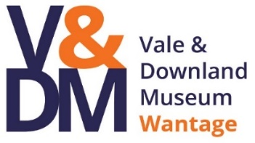
Church Street, Wantage, Oxfordshire, OX12 8BL
Telephone: 01235 771447
Email: learning@valeanddownlandmuseum.org.uk
Website: www.valeanddownlandmuseum.org.uk

Adult Group Booking Form
*Please note group bookings are charged at £7.50 per person with a minimum total spend of £45.00 per group*

Name of Group or Organisation

Address

Contact Name

Contact Telephone Number

Email Address

Date of Visit

Time of Arrival

Time of Departure

Number of Visitors (@ £7.50/head min spend £45.00)

Total group booking cost

Session/Subject areas/Event required

Any special requirements

Will the group require Café facilities?
(Tea/coffee, cakes, lunches – please advise)

Signed

Dated

